|  |  |  |  |  |  |  |  |  |  |  |  |  |  |  |
| --- | --- | --- | --- | --- | --- | --- | --- | --- | --- | --- | --- | --- | --- | --- |
| **MAD Project Evaluation 2 – Regular Intake 2021** | | | | | | | | | | | | | | |
| **Project Name:** | **<Group name>** | | **Batch:** | **<Lecture Group>** | | | |  |  |  |  | | |
| Student ID | Student Name | Integrated system using a repository (Out of 5) | Marketing the app using a video clip published in a social media account (eg: LinkedIn) (Out of 10) | CRUD Function completeness (Out of 20) | Database connectivity (Out of 5) | Usability (Out of 5) | Validations (Out of 5) | Good coding practice (Out of 5) | Out of box features (Out of 10) | Test cases (Out of 10) | Report (Out of 10) | Q & A (Out of 15) | Total (Out of 100) |
| <ITxxxxx> | <student 1> |  |  |  |  |  |  |  |  |  |  |  |  |
| <ITxxxxx> | <student 2> |  |  |  |  |  |  |  |  |  |  |
| <ITxxxxx> | <student 3> |  |  |  |  |  |  |  |  |  |  |
| <ITxxxxx> | <student 4> |  |  |  |  |  |  |  |  |  |  |
|  |  |  |  |  |  |  |  |  |  |  |  |

Git Repository Link: <Add your Git repository link here>

Link for the video in social media: <Add URL for your video published on social media here>

----------------------------------------------------------------------------------------------------------For Evaluators--------------------------------------------------------------------------------------

Evaluator’s name:

Comments:

Add the calculations/algorithms included in the project.

**Introduction to the Project**



Purchasing expensive products for short term use is not a viable option for many people. Therefore, many tend to rent the products when necessary. However, as we all have experienced, finding a product to rent is a tedious task. “Huwamaruwa” is a product rental app focused on Sri Lankan community that connects product owners and customers directly. The main intention of this app is to streamline the product rental process while exposing new opportunities for ordinary people to earn an extra income by renting out the products they own. They can rent out household products under several categories such as electronics, kitchen wares, outdoor tools and books. This app also enables equipment rental shops and individuals to take their operations online with a mobile-first rental solution.

“Huwamaruwa” app allows customers to easily discover products they are looking to rent, see their availability and rental prices through the online store. In order to enable equal opportunities to everyone we are planning to implement, two types of rental products known as Premium and non-premium. As the rental process involves some risk and products should be handled properly, we have implemented premium products category where our service team acts as middle party between customer and the product owner. Moreover, our delivery team picks up the product from the owner and delivers to the customer. The products are carefully inspected before delivering and returning. This ensures the safety of the product and the seller’s lost will be covered in case of product damage. Premium product customers will always get quality products at an extra cost.

Non-premium products don’t involve our intervention and seller and buyer should arrange the deal themselves. This category connects both parties directly and we expect this feature may persuade many people to use the app.

Product owners can list the items and send offers to buyer requests. They can also manage all necessary functions such as edit or delete listings. Buyers can rent products, review them or request new products. Once reservations have been made online, premium product customers can pay for their rental through the app. A variety of methods, from credit cards to cash on delivery are supported. Admin functions such as delivery management and customer support are also built into the app.

There are four main functionalities we identified in this system

* Product request and customer and seller management
* Product Rental and Payment Management
* Product listing and Category Management
* Product review, Delivery management, Customer Service, Listing management by Admin

**IT<xxxxx> - Product request and customer and seller management**

CRUD operations

In our rental system the management of user accounts are done by myself and the new product requested by customers are handled by myself. So, in this case if a product is not listed in our listings a customer can request for a product.

The product requests are handled within my function. Here a form is directed to the user to add the new product request. The requests are visible for the seller, so seller can send offers to these listed requests.

Read

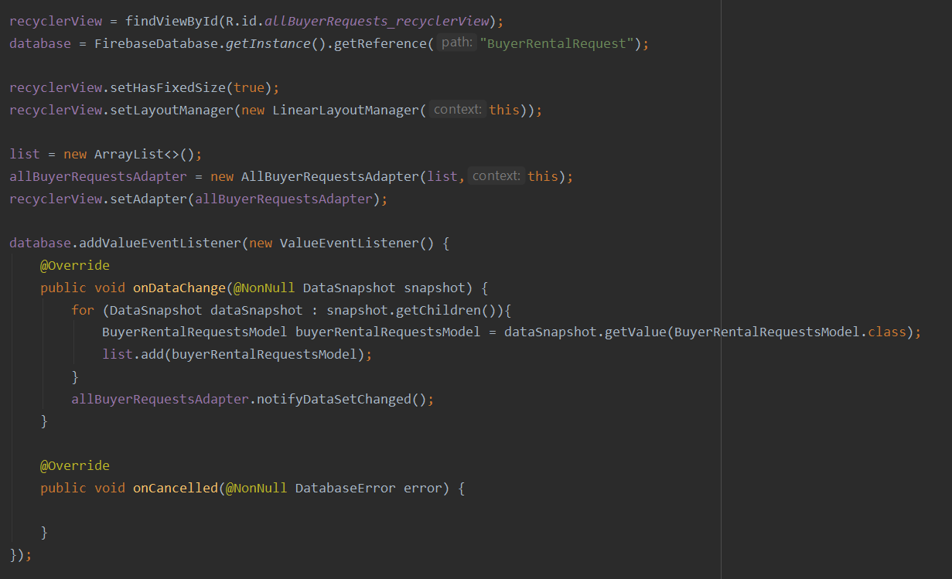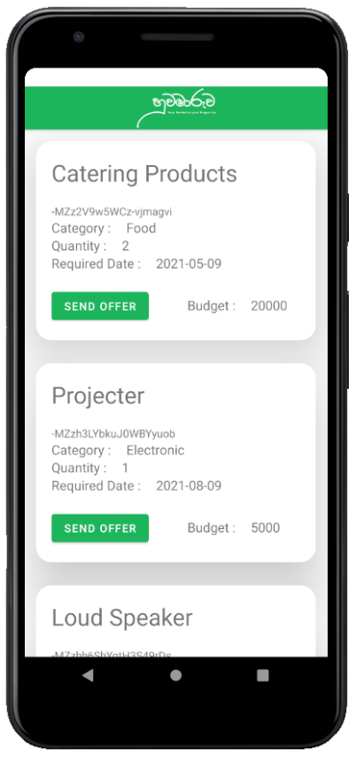

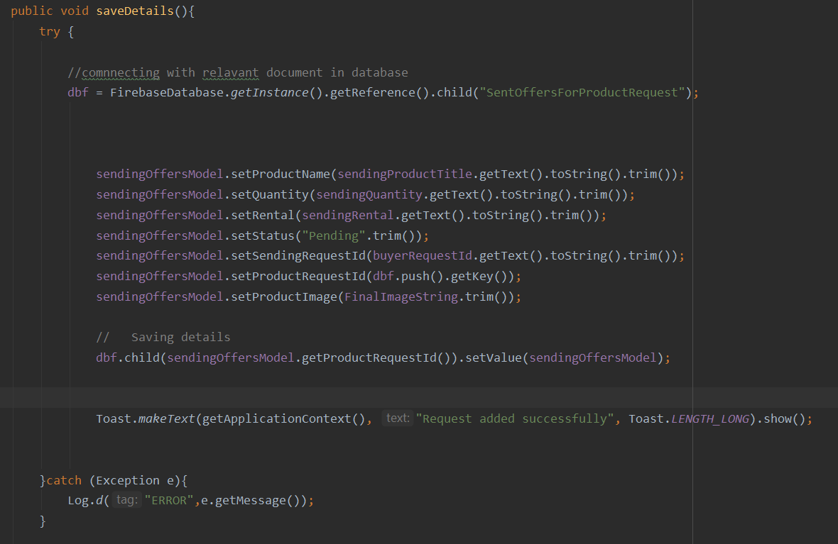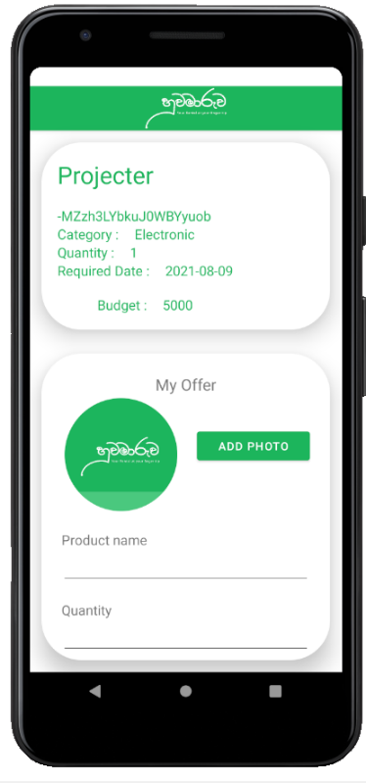

The requests send by the sellers can also be updated and deleted by themselves.

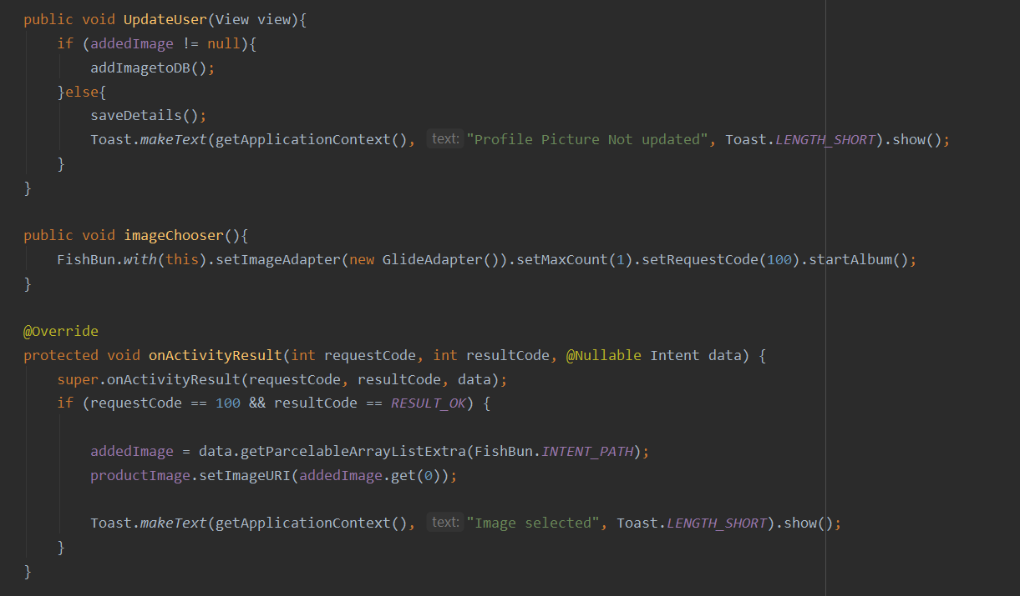

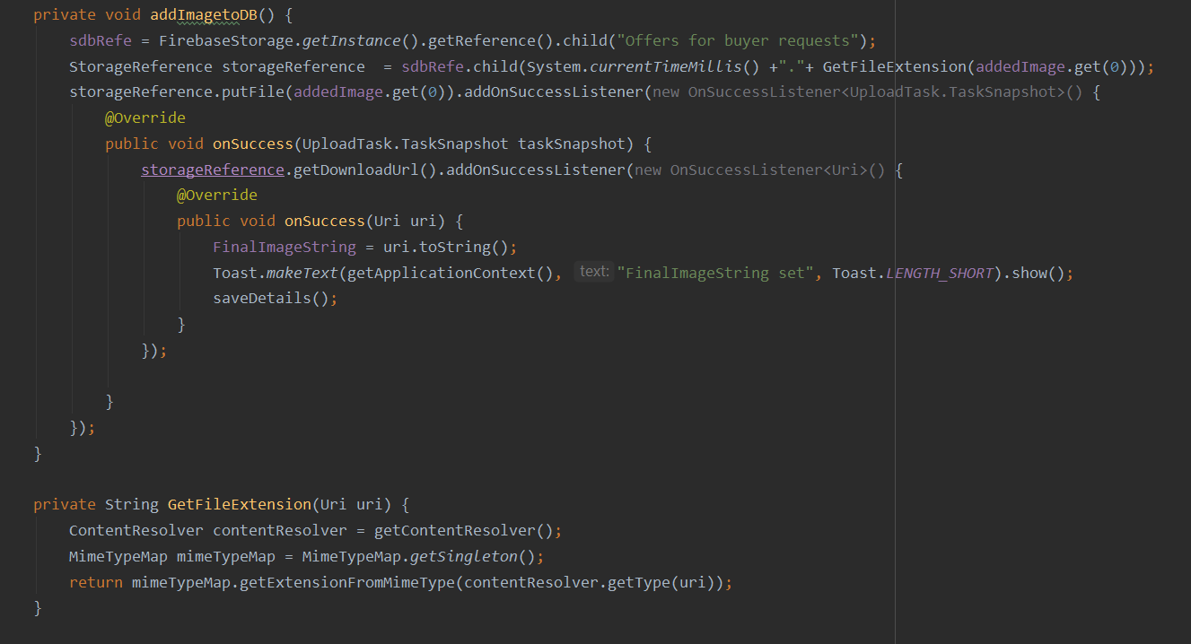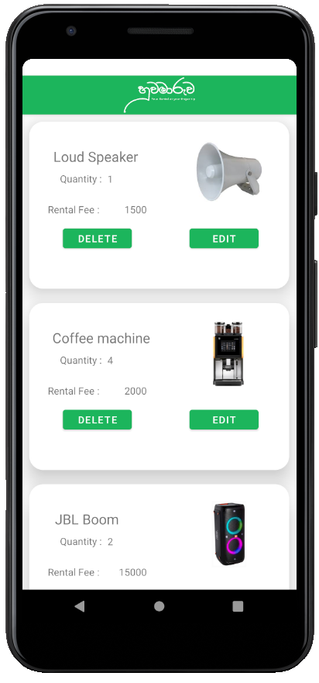

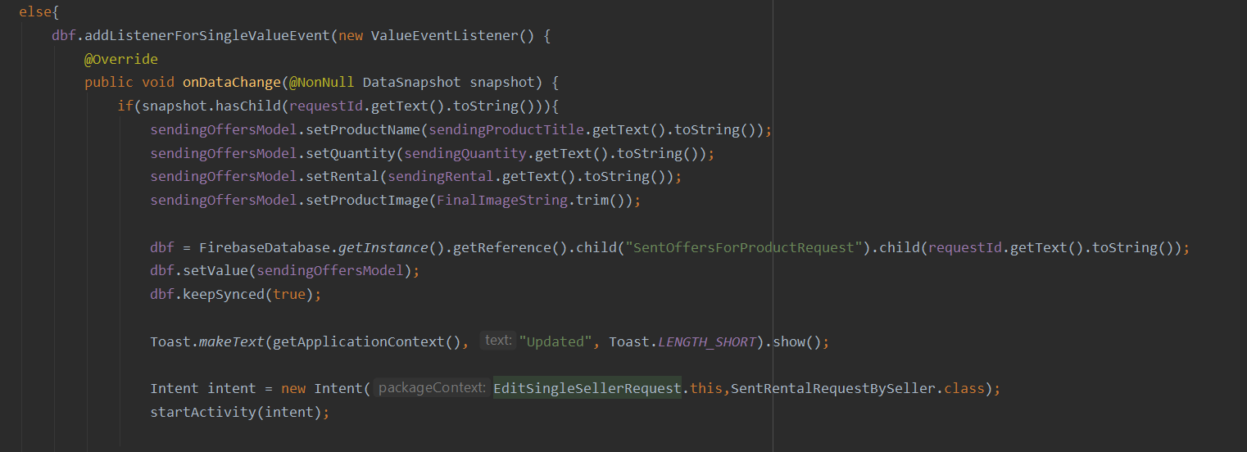

Delete function

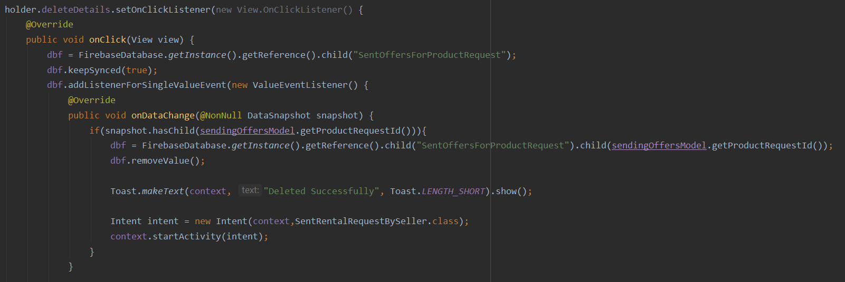

The management of user sessions and user accounts are also handled by myself. Here the applications such as updating profile details and deleting user accounts are handled here.

Evaluator’s comments : Add the additional features and test cases you did for your component.

**IT<xxxxx>- Product review, Delivery management, Customer Service, Listing management by Admin**

Product review, Delivery management, Customer Service

After the product has been successfully returned, a notification is sent to the user asking to review the product. The user can rate the product using stars and give a brief description about the experience. User can view other customers’ reviews on a product and able to edit or delete his/her previous reviews. Calculations are don’t to obtain the average rating of a product.

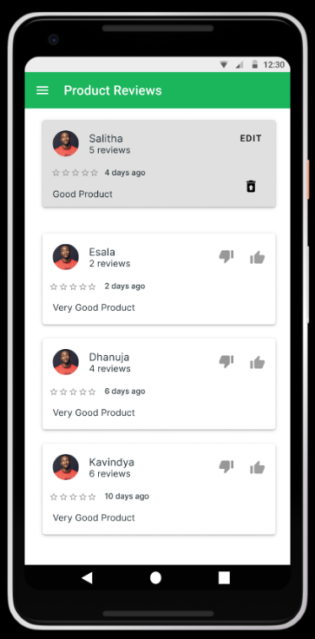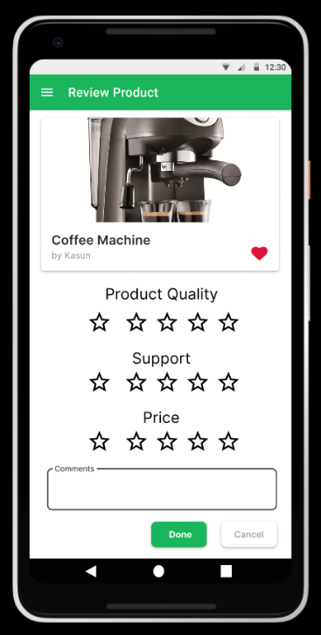

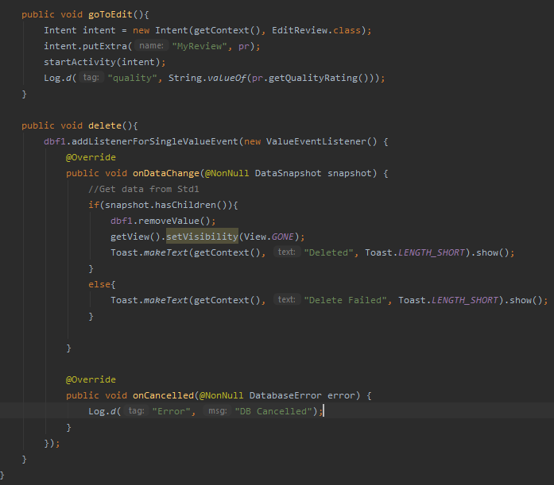 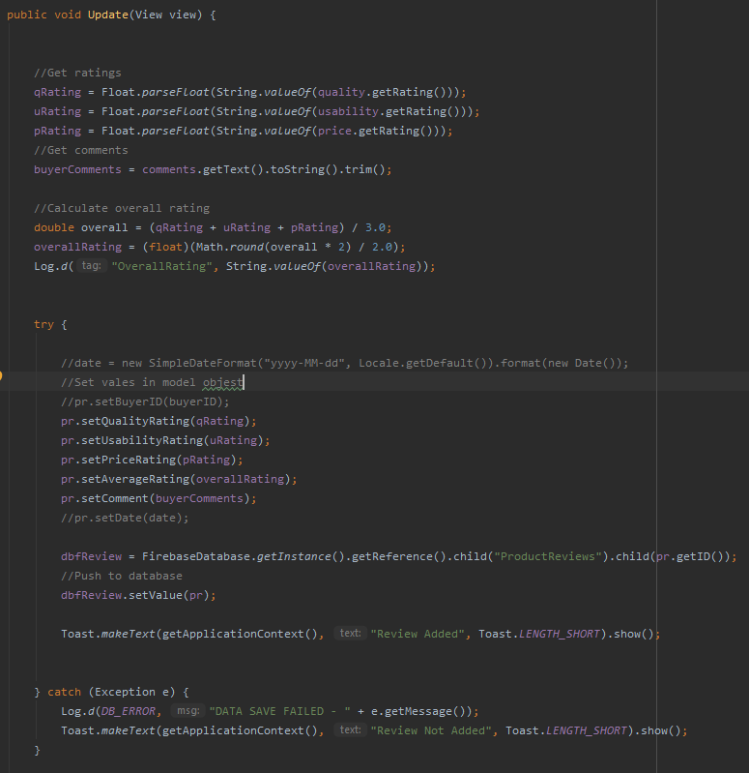

Delete Update

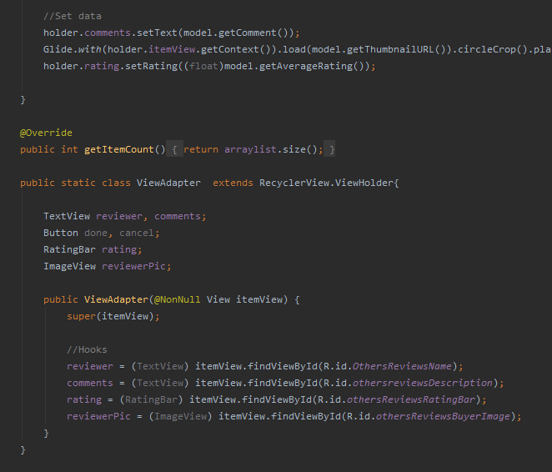 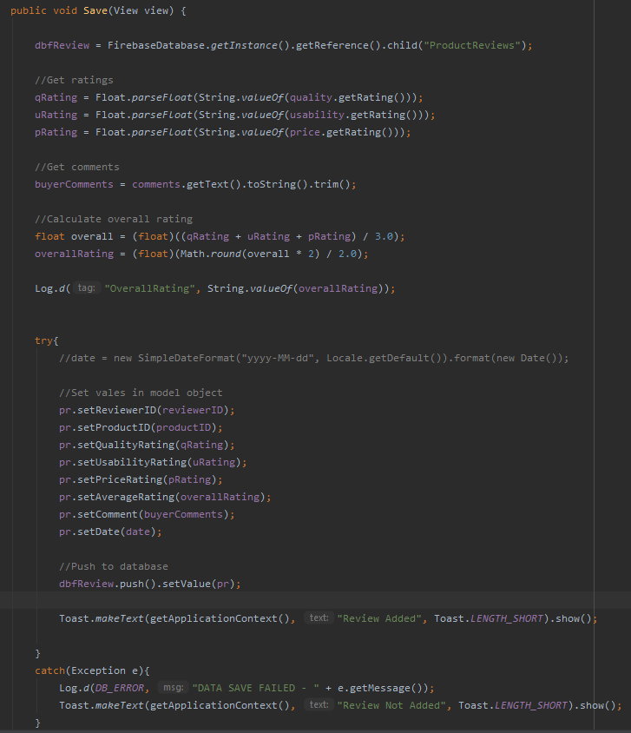

View Add + calculation

Test cases –

* No input for rating – Toast message displaying error and data not saved.
* More than 5 ratings for one criterion – Toast message displaying error and data not saved.
* Words in comment section exceeds 200 – Display error message and data not saved.
* Empty comment section – No error data submitted.

A pop up appears to confirm user actions. Sellers will also be able to rate the customers by visiting the rate customer section orders section. They can rate using star rating system. Buyer reviews will be displayed in the buyer’s profile and will increase the reputation. User can perform CRUD operations on these functionalities as well.

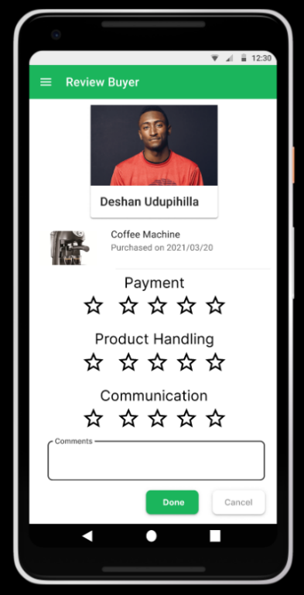

Once the product has been accepted by the delivery team, the delivery details are displayed to both admin and user. When the delivery agent updates the delivery status, the updated delivery details are displayed to the user.

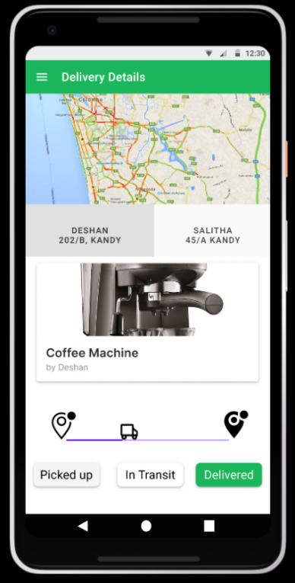

Customers can chat with customer care agent to resolve their issues though the real-time chat system available in the app.

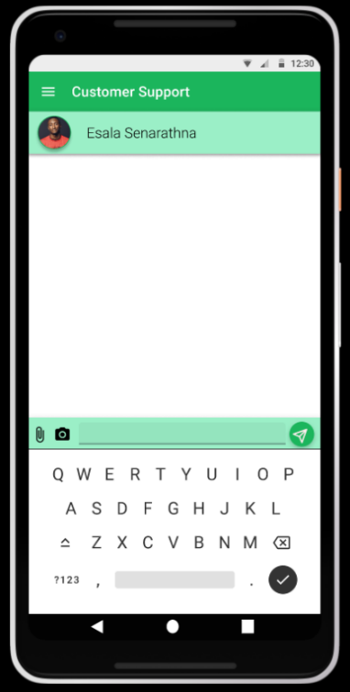

Some UI components from the phase 1 has been removed as I though they would make the interface more complex and leads to an unpleasant user experience. As planed in the phase 1, the real-time location of the product is shown to the user, but that feature has been removed as it required to pay Google to use that feature.

Evaluator’s comments : Very good. Test cases should be clearer.

**IT<xxxxx>- Product Rental and Payment Management**

The products are listed in the system the process of renting a product id handled in this function. When a user clicks on a product,

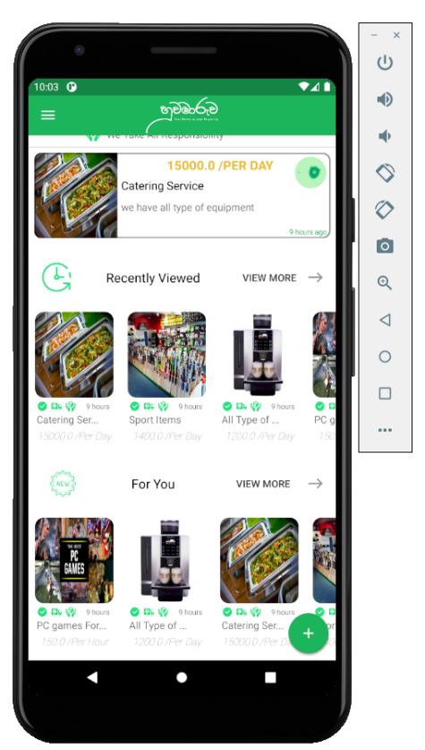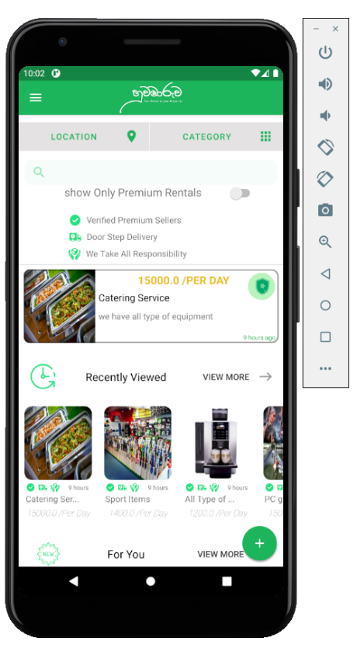

he is directed to a single product interface.

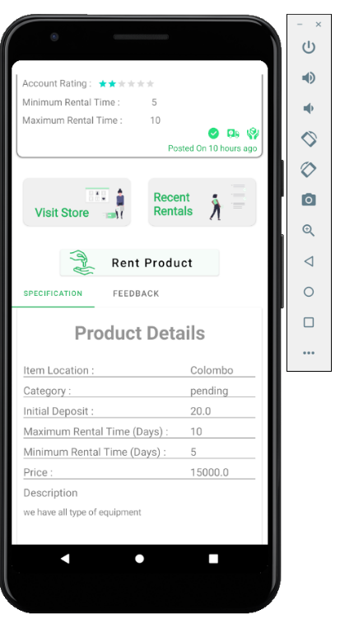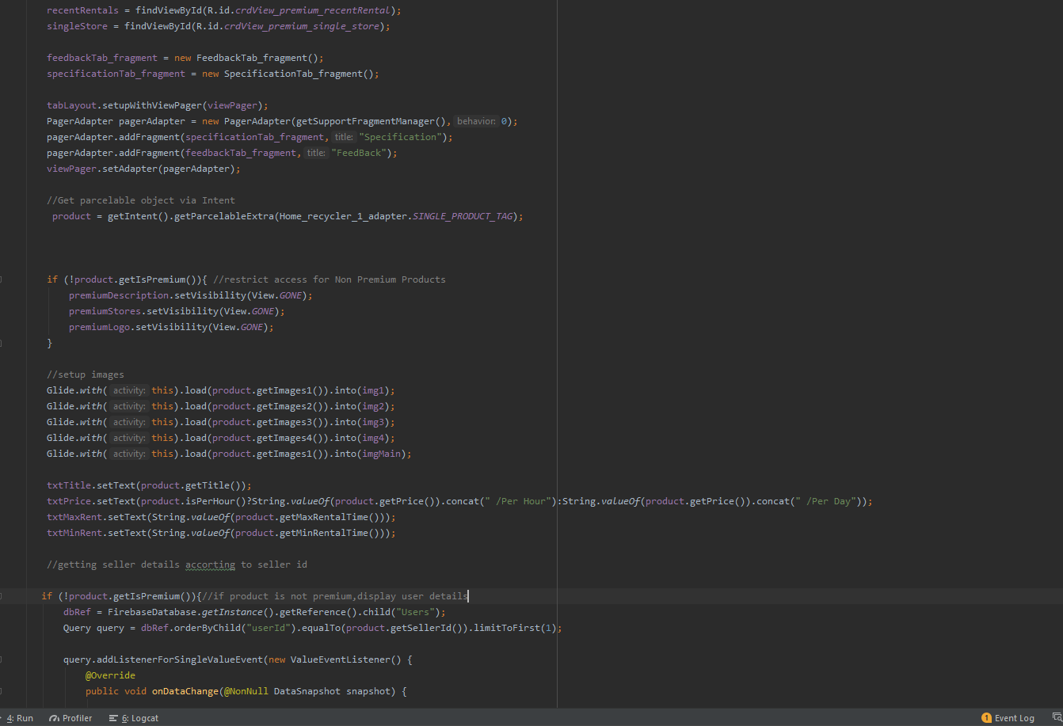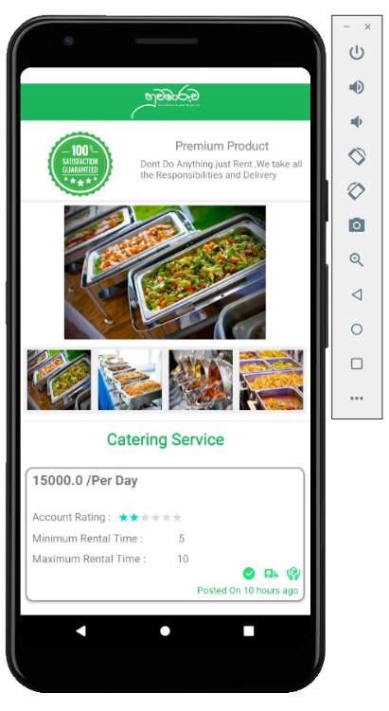

When he clicks on the button rent a product the request is redirected to a form. According to the deposit percentage, and rental time duration, initial deposit will be calculated dynamically.

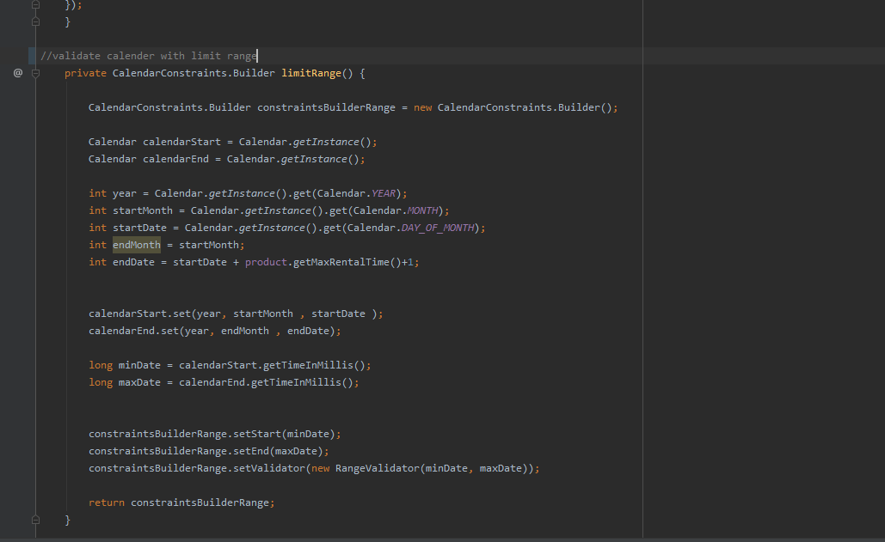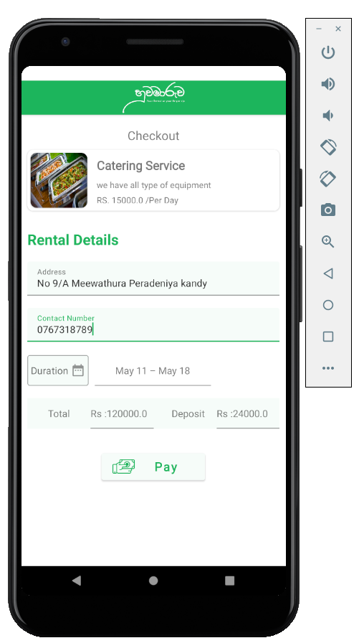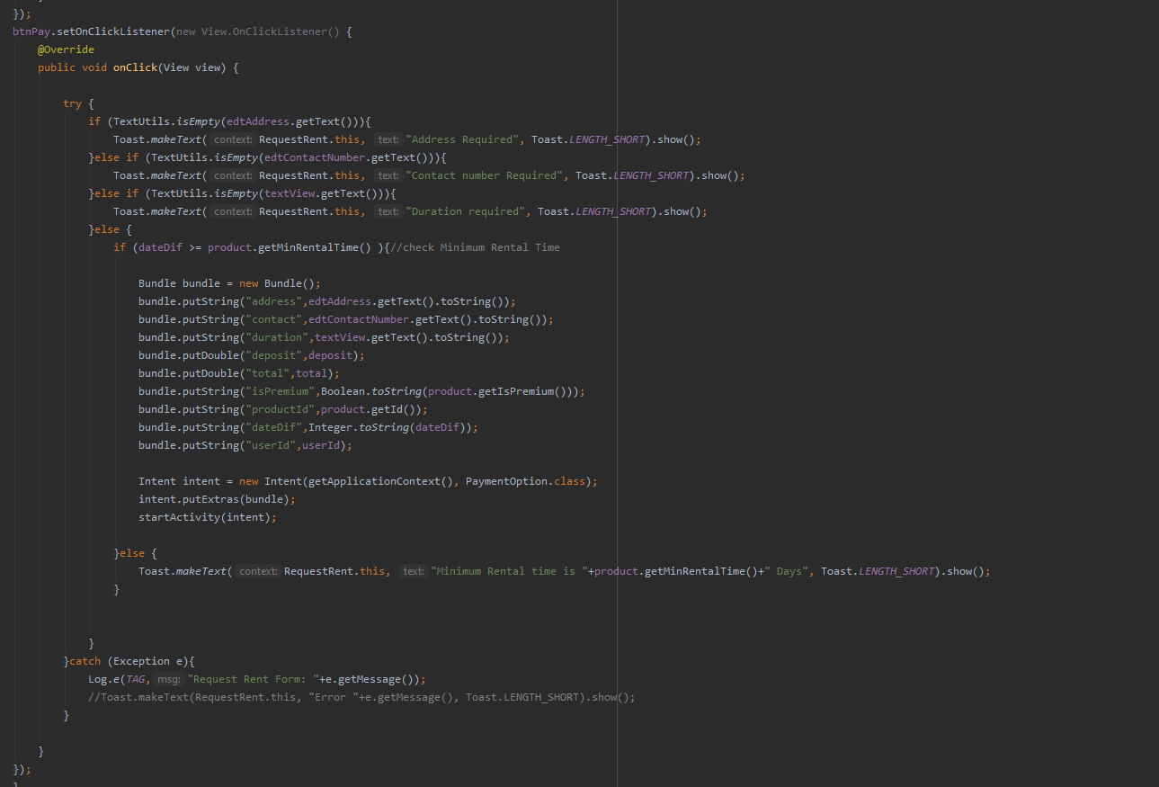

Next a payment option and details should also be added.

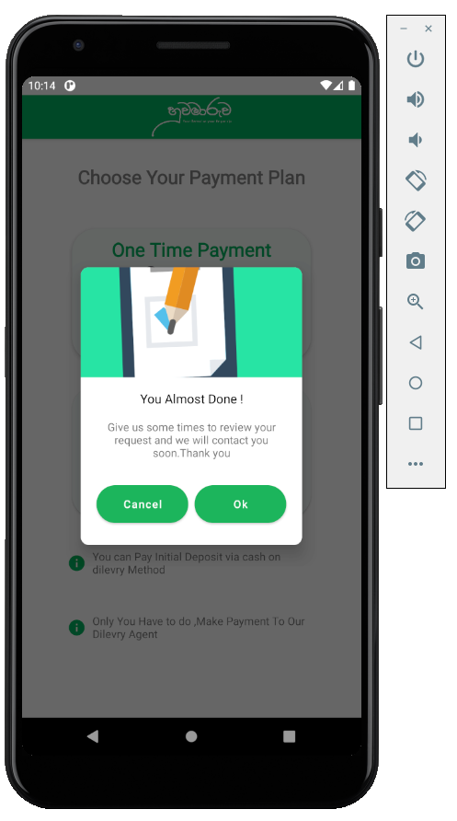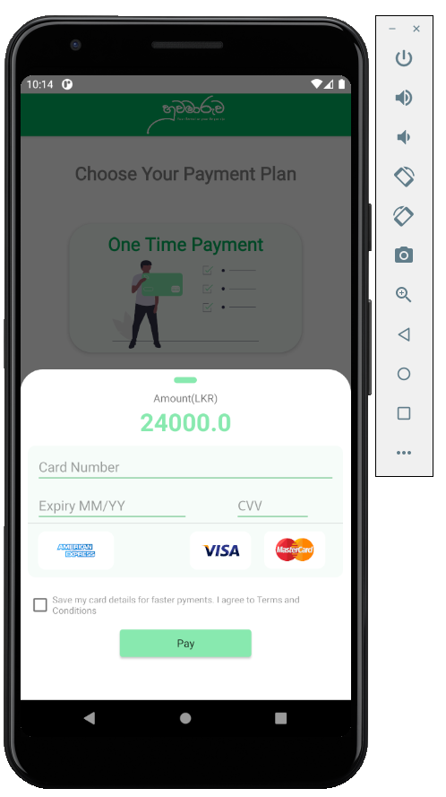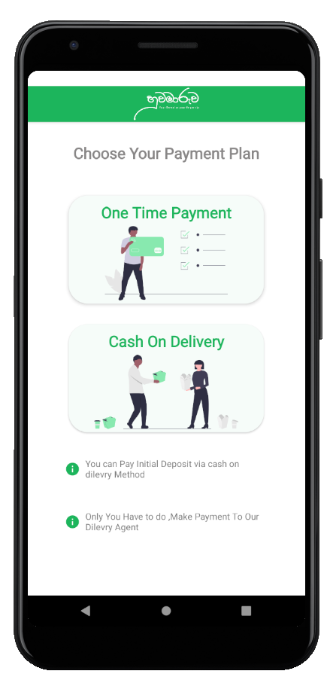

At this point request details are added to the database.

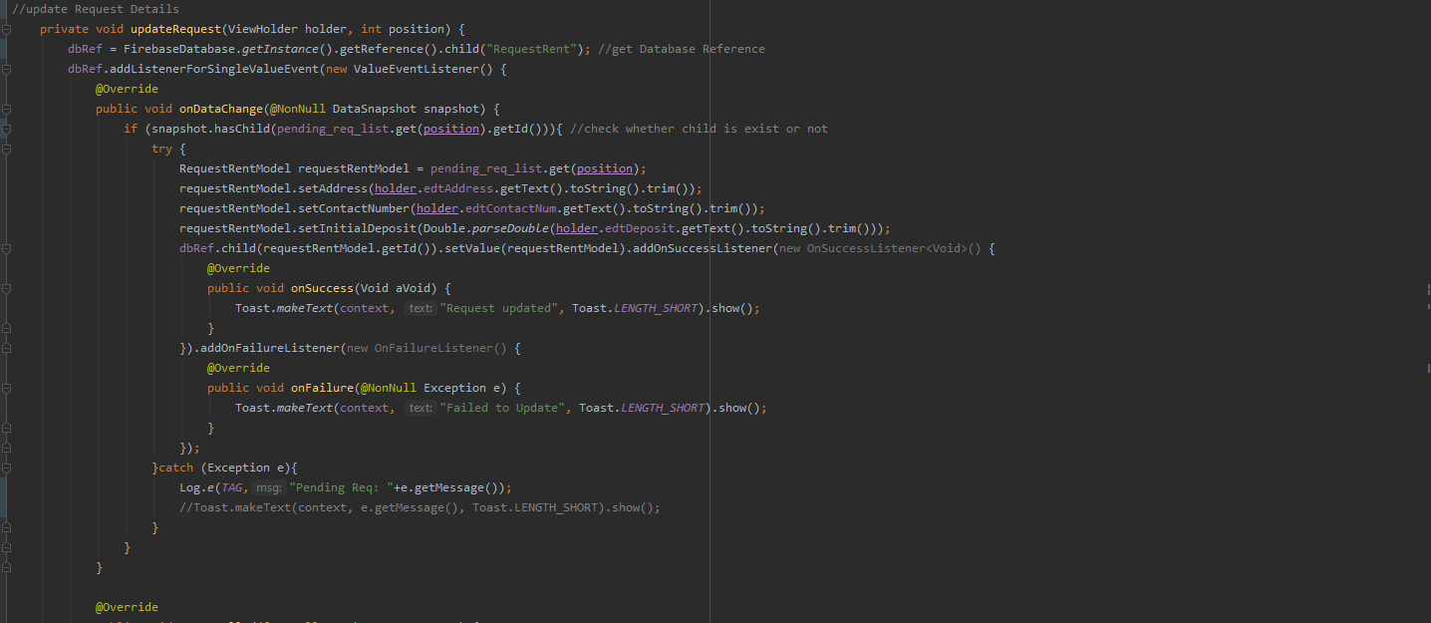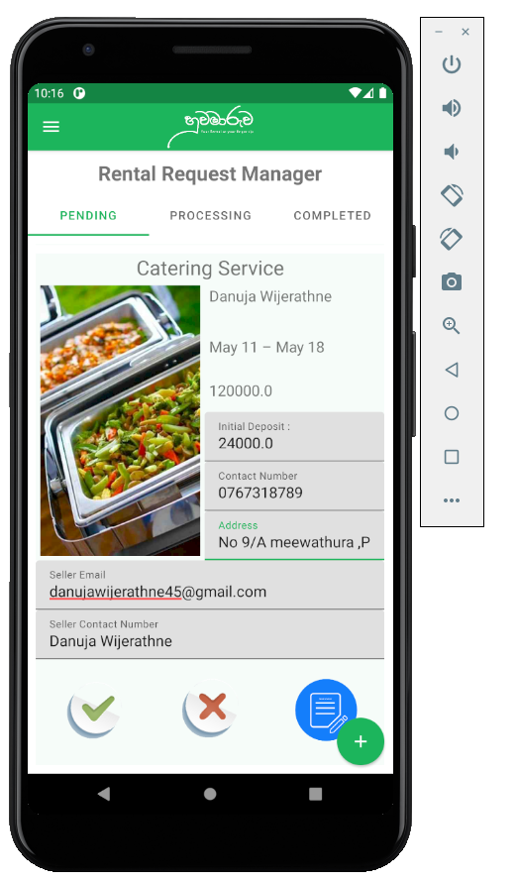

If the request is from a premium product then the admin panel can view the request and review it, and if the request is a non-premium then the product owner can review it. In the process of reviewing the request can be update, accepted or deleted

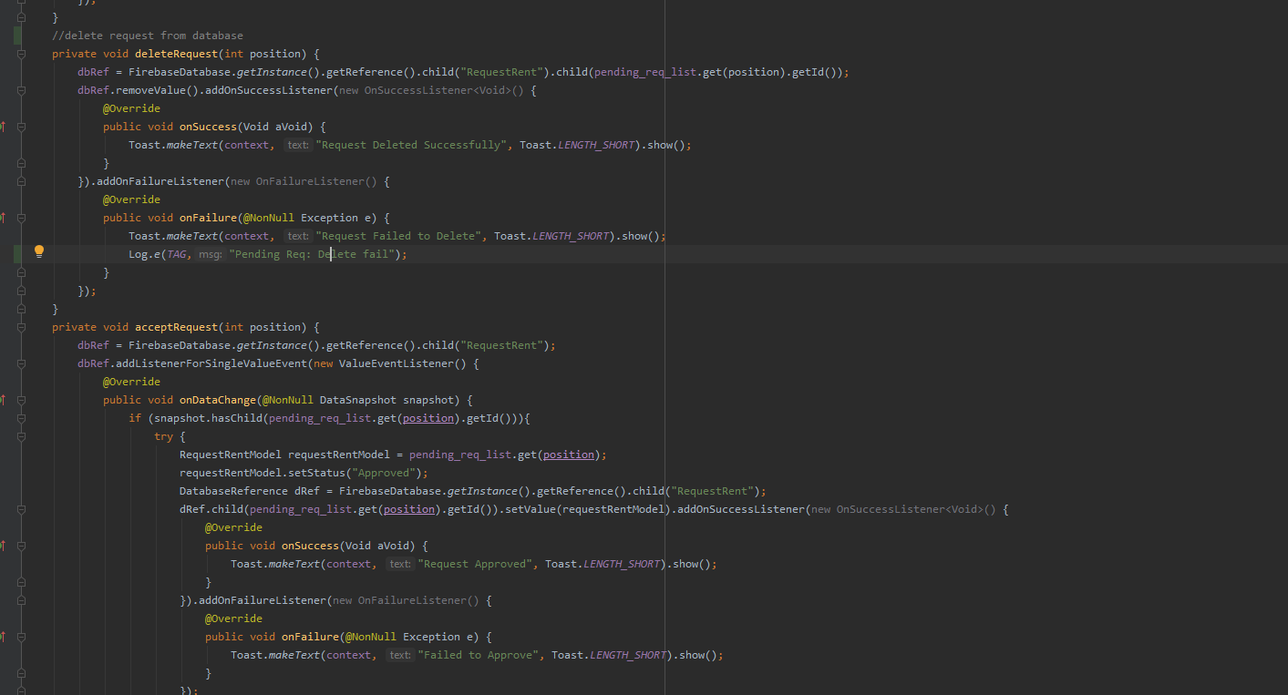

At this point a notification is sent to the user. A seller with premium products has a store and, in that store, the premium products of that seller is displayed. and he also can delete his previous rental histories according to the products.

In the new User interfaces UI/UX principles are mostly used , because of that a better user experience is given to the user

Evaluator’s comments : Add the additional features and test cases you did for your component.

**IT<xxxxx> – Product listing and Category Management**

The functions related to product management is handled by this section. In the home screen when the user clicks on the post advertisement floating button the user is directed to a form and there the product details will be added.

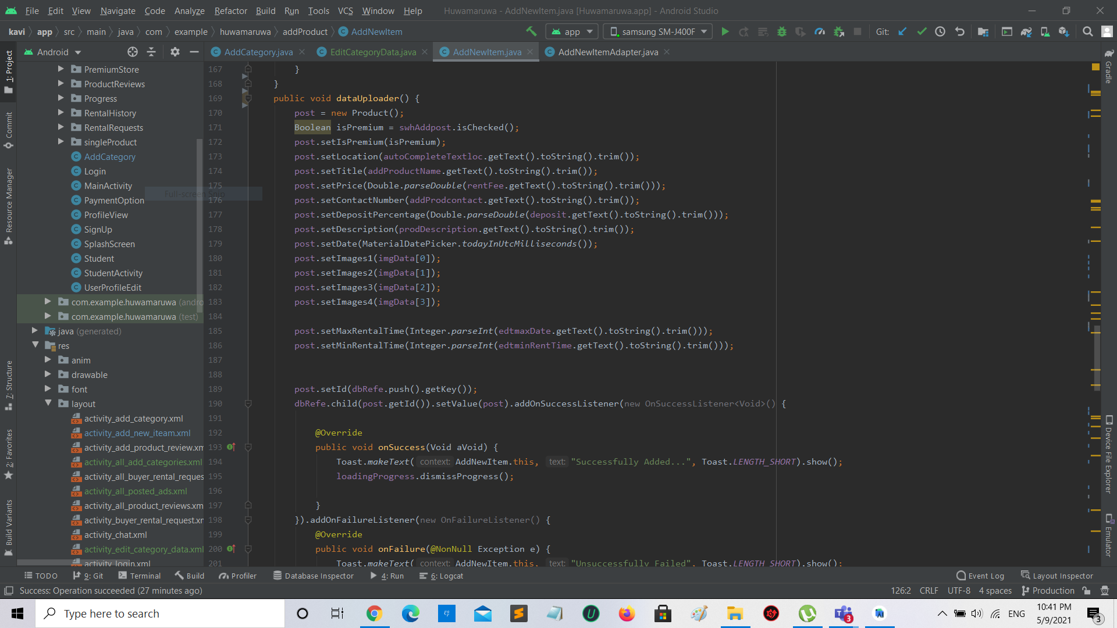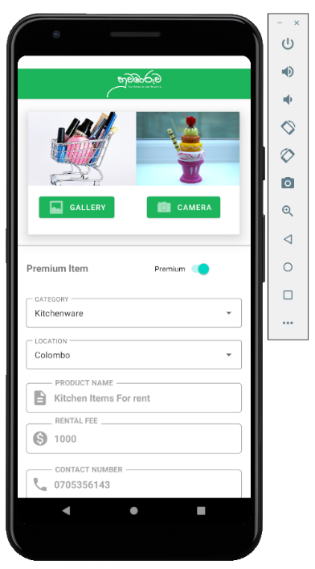

Products added to the system according to categories. These categories must be add to the system and that section is implemented. Here an admin adds the categories

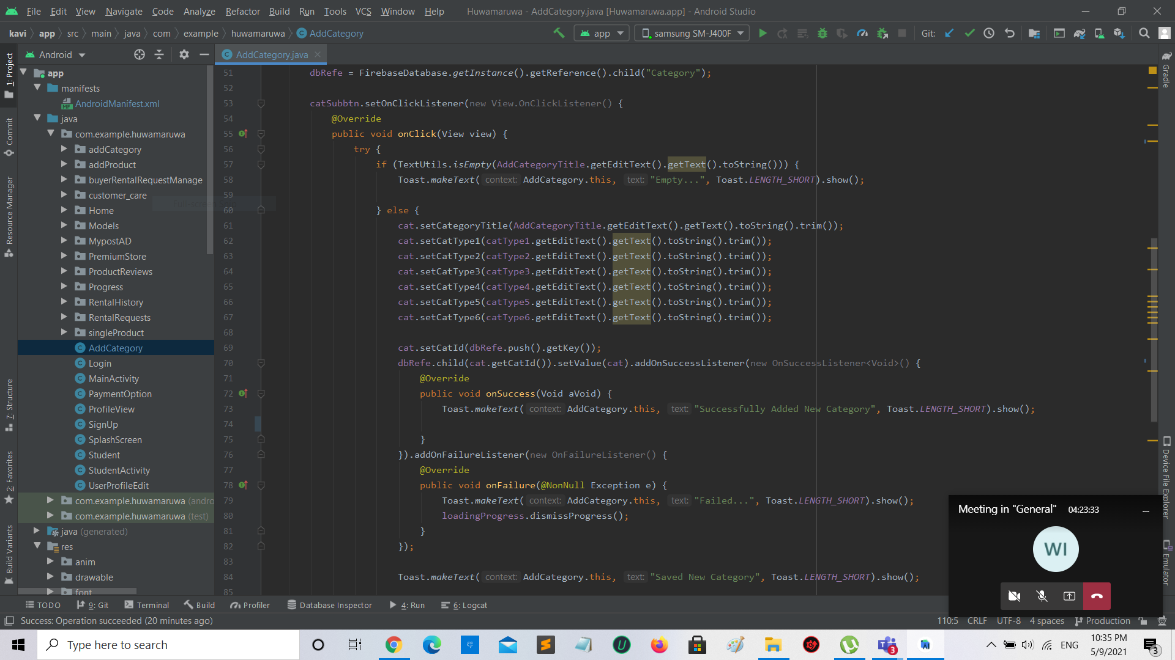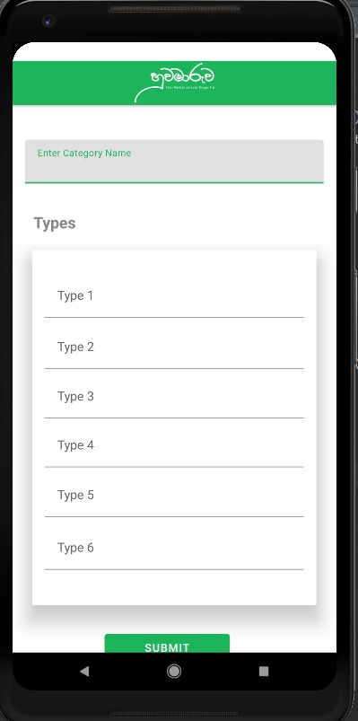

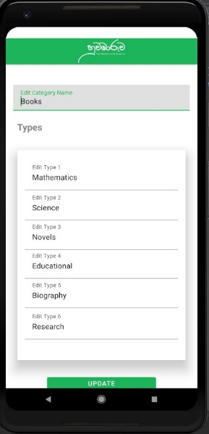 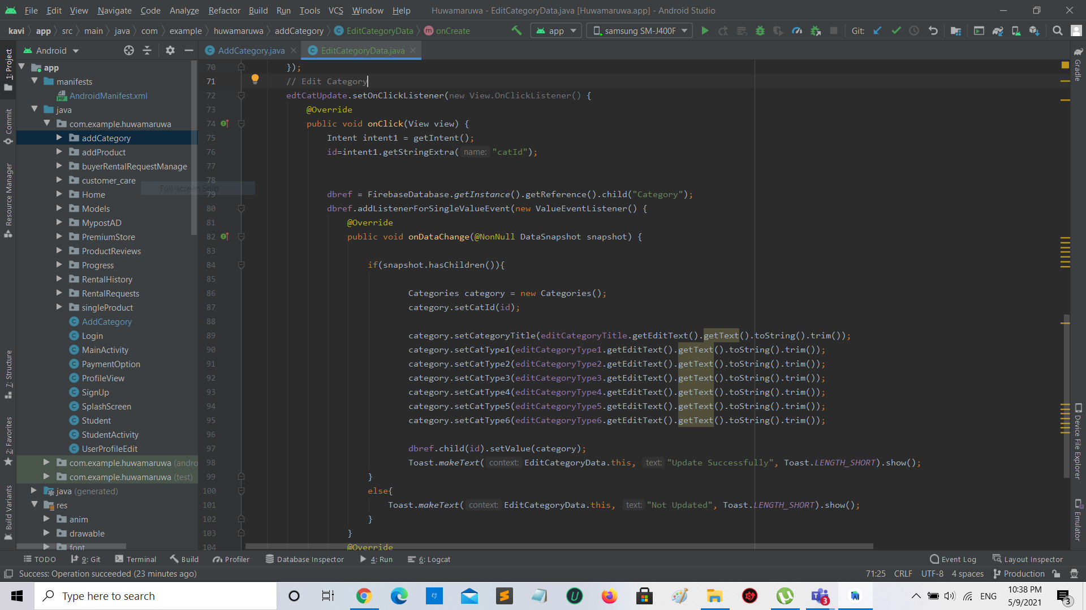

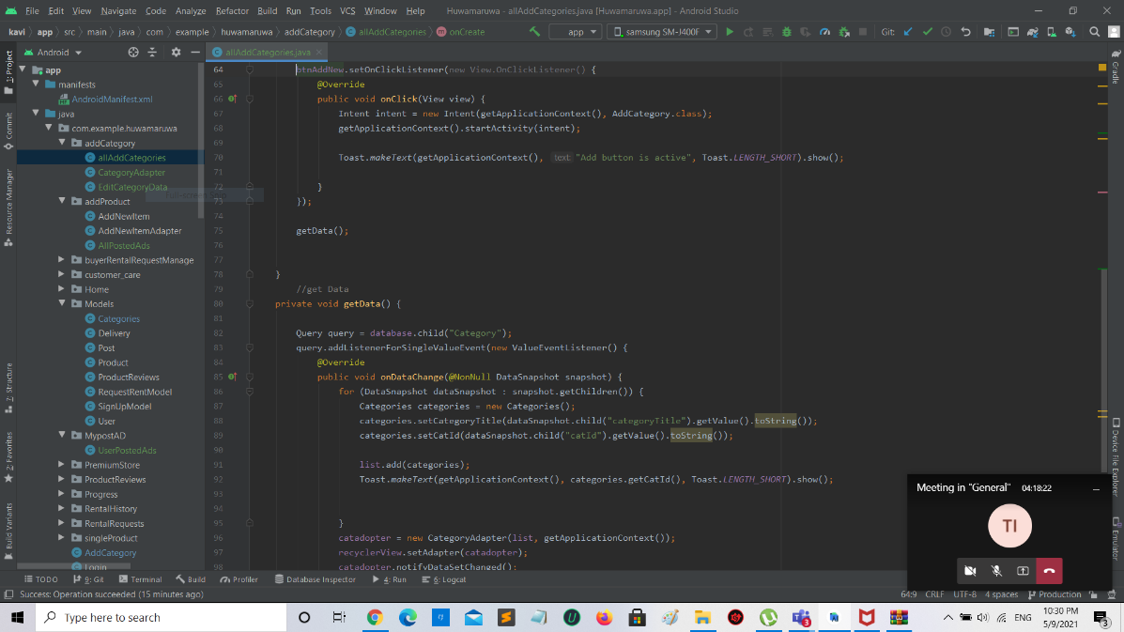

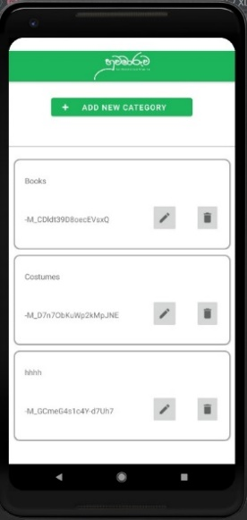

and all the updates and the deletions are also handled here.

Evaluator’s comments : Add the additional features and test cases you did for your component.

**GitHub Commit Graph**

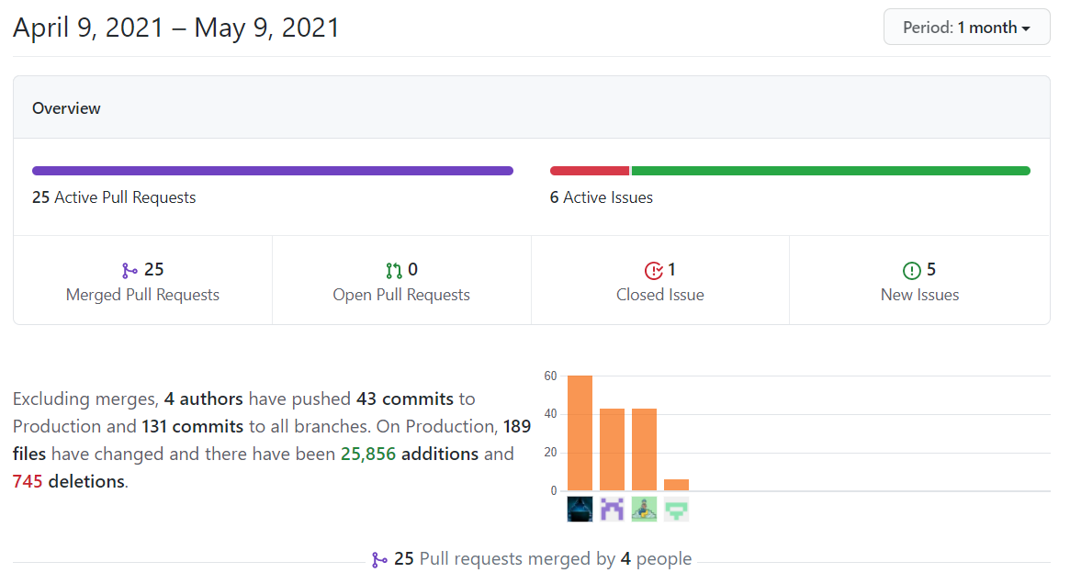

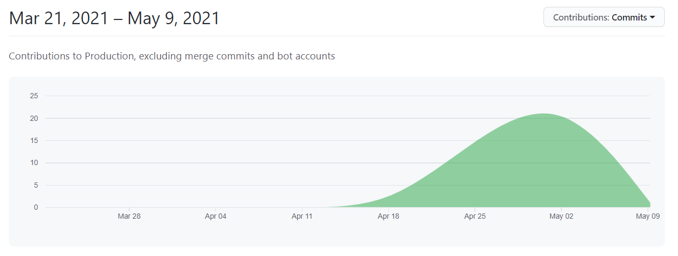

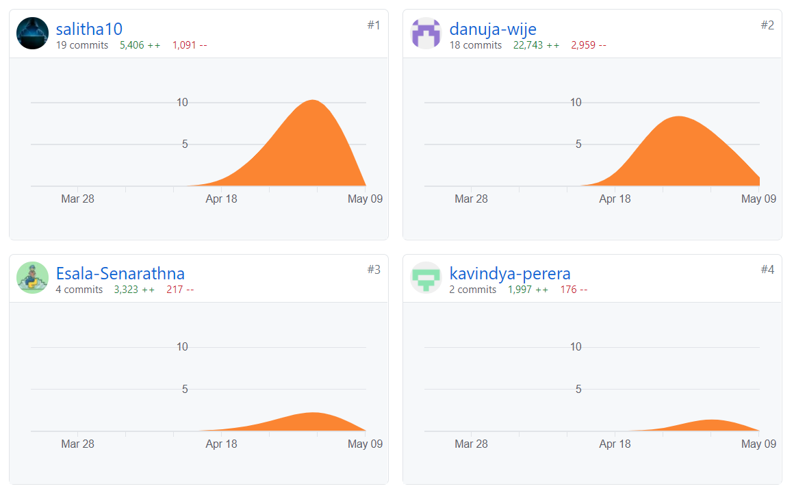

**Individual commits**

<ITxxxxxx>

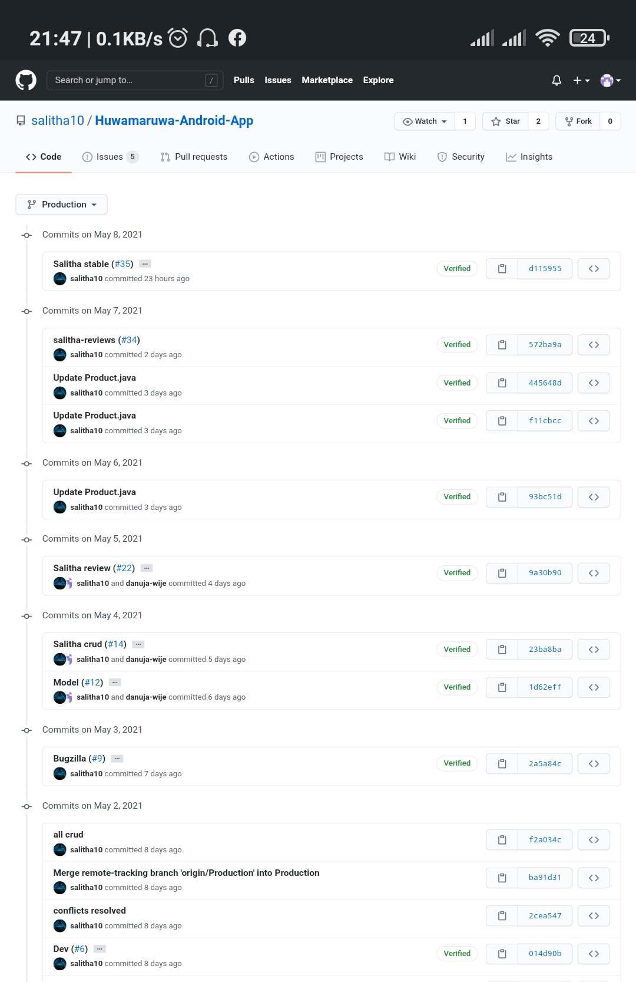

<ITxxxxx>

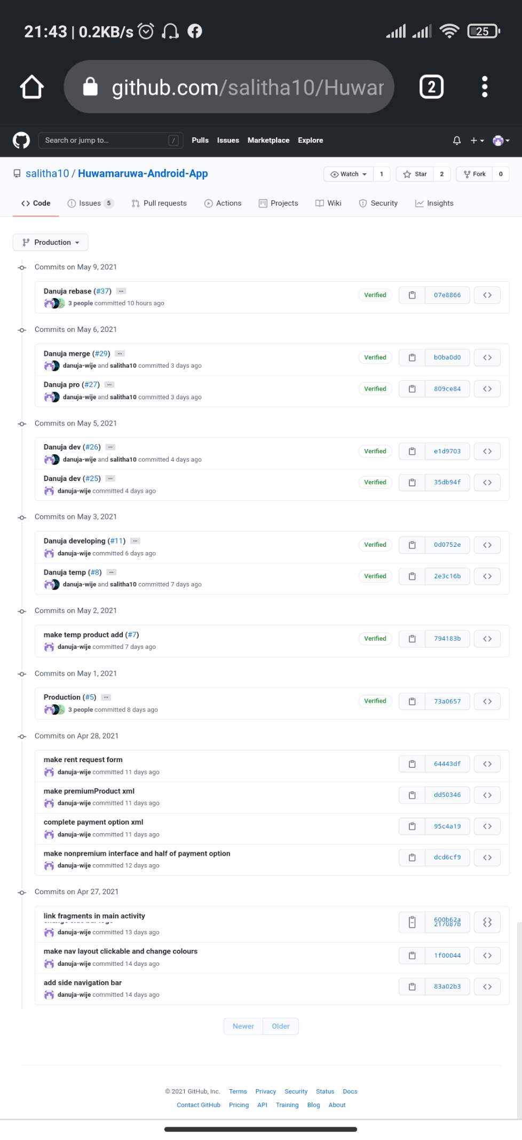

<ITxxxxx>

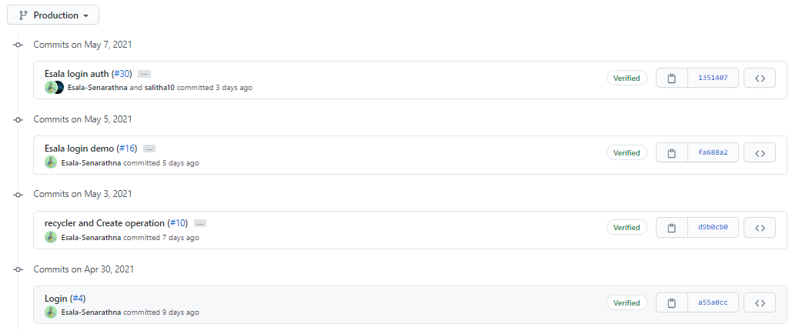

<ITxxxxx>

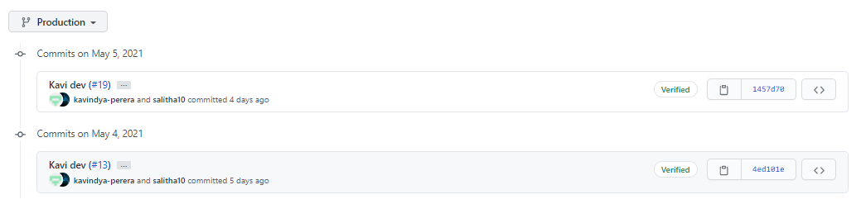

Changes from the first evaluation.

Evaluator’s comments : Explain!

